Boone County 4-H Awards Program
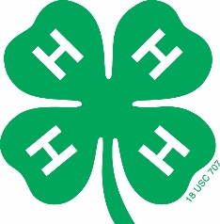
Application Instructions

Award applications are not required, but rather a way for 4-H youth to be recognized for the work they have done throughout the 4-H year. We encourage ALL 4-H members to apply for awards. Many of the project areas have special awards which may include trophies, plaques, cash prizes, or other award of donor’s choice.

The following will make up a completed award application:
- Boone County 4-H Award Cover Page
- Application with Sections 1-3
- 4-H Story (one for each area applying for an award in)

Please note: The application Sections 1-3 cannot be changed. Please do not adjust columns, margins, or lines. If you have more information then will fit in the allotted space, you will need to prioritize and just include the most important items. This part of the application is based on the past 3 years and covers your 4-H project work, club activities, county events and activities, and all state and national events as well.

4-H Story:
You will need to write a 4-H story for each of the projects that you want to apply for an award in. For example, if you applying in photography and swine you will write one story for photography, and one for Swine. In addition, if you are applying for an Outstanding Member Award (Achievement) then you will also need a 4-H Story on your overall 4-H experience. Please be sure each 4-H story is labeled with the project name.
What is important in the 4-H Story? The story is where you will want to share details about your project or 4-H career. It should include information on how 4-H and your project work have helped you personally and your family. How has it affected your future? Do you want to continue to learn about a subject area or has what you learned helped you in a career choice? How have you used what you have learned in school, other organizations, your job, or everyday life? Be sure to make it personal! The reader should feel like they know you by the time they finish reading your story. You can tell your story using straight facts, or demonstrate creativity.

Boone County 4-H Awards Cover Page

Name: Club T-shirt size_______

4-H Age (age as of previous year Sept. 1): __________ Number of years in 4-H, including this year:

Boone County Project Honor Awards:
Please circle each award(s) you are applying for. Please write a story for each award area circled. For example, if you apply for Achievement, Dairy, Community Service, and Visual Arts, you will need to write 4 stories. You must be enrolled in the project area and completed project work to be eligible.

- Achievement or Outstanding 4-H Member
- Aerospace
- Agriculture
- Beef, Outstanding Beef Exhibitor
- Bicycle
- Cat
- Cavy
- Citizenship
- Clothing, Clothing & Textiles Award
- Community Service
- Computer Science
- Consumer Education
- Dairy, Outstanding Dairy Exhibitor, Illinois
Holstein-Friesian Assoc. Award
- Dog, Dog Award
- Electricity, Electricity Achievement Award
(must include EEC Award Application)
- Engines & Tractors
- Entomology & Beekeeping
- Environmental Stewardship, Natural Resources Award
- Food & Nutrition, Food & Nutrition Award
- Forestry
- Gardening & Horticulture, Horticulture Award
- Goats, Goat Award
- Geology
- Healthy Living
- Hobbies & Collections
- Home Environment (Interior Design)
- Horse, Outstanding Horse Exhibitor, Most
Improved Youth in the Equine Division, Phyllis Van Brocklin Memorial Award, Judy Lee Memorial Award
- Industrial Arts (Welding)
- Judging
- Leadership
- Outdoor Education & Recreation (Camping)
- Performing Arts (Theater Arts)
- Pets
- Photography & Video, Photography Award
- Plant Science (Crops), Soil & Water Conservation Award
- Poultry, Poultry Award
- Public Speaking, Public Presentation Award
- Rabbits, Rabbit Award
- Sheep, Outstanding Sheep Exhibitor
- Shooting Sports
- Swine, Swine Award
- Technology & Engineering (Robotics, 3-D Printing, and Drones)
- Veterinary Science, Veterinary Science Award
- Visual Arts, Visual Arts Award (includes Food Decorating and Scrapbooking)
- Wildlife & Fisheries, Sportfishing Award
- Wood Science, Woodworking Award

*** PLEASE NOTE---The above list awards available is subject to change based upon the availability of sponsors.

Boone County Outstanding 4-H Member Awards:
You can only receive each of these awards one time.
Note: Requires Award Applications with 4-H Achievement Story.

_____First Year Member, ages 8-11
_____Jr. Member, ages 9-10
_____Pre-Teen, ages 11-12
_____Mid Teen, ages 13-14
_____4-H’er of the Year, ages 15-16
_____Don Paulson Award, ages 17-18
_____I Dare You, ages 15-18 – must include a one-page letter of recommendation from 4-H leader

Special Opportunity -- During National 4-H Week, the local newspaper, Belvidere Daily Republican, publishes a special 4-H insert. 4-H’ers stories should be submitted by email to the Extension Office to be considered for publication in the newspaper. Please include a picture to go with your story. Stories and pictures will be chosen at the discretion of the newspaper staff. Please email the photo as a jpeg to mmirwin@illinois.edu.

Section 1: 4-H Project/Program Summary
In this section, list your top projects (i.e. Woodworking, Cooking 401, etc.) or programs (i.e. Teens as Teachers, Teens as Mentors, 4-H Federation) within the past three years of your 4-H membership. Show size or scope of the projects or programs by number of animals owned/leased, dishes prepared, articles made, youth taught/mentored, events planned, etc. (Individual 4-H Show exhibits/results should not be included). (30 points) Do not add lines to this section!
Year | Name of Project/Program | Project/Program Size or Scope  (what I made, did, raised or cared for, # taught/mentored)
2015 | Example: Cooking 401 | Made 200 recipes; Prepared 52 meals/4 people; Catered 3  parties

Section 2: Participation in Other Community/School Activities/Events
Include your participation in sports, band/choral, school clubs, drama, other youth organizations, religious groups, etc. from the past three years. You can also include any employment you’ve had. Tell what you did and the skills you learned. Check all locations that apply. L = Local club or community; C = County; M = Multi-county/Unit; S = State; N = National; and I = International. (30 points) Do not add lines to this section!
Year | Kind of Activity | What I Did & Skills Learned | L | C | M | S | N | I
2014-15 | Example: Spanish Club | Secretary, fundraising, Trip to Mexico, cultural learning | X |  |  |  |  | X

Section 3: Participation in 4-H Events/Activities
Include training activities, workshops, clinics, field trips, and special club or program activities and events during the past three years of 4-H membership. Show where you participated (L = Local Club; C = County; M = Multi-county/Unit; S = State; N = National; and I = International) and also indicate things learned. Do not include 4-H show results. Activities that have occurred during multiple years may be grouped onto one line with years noted like the Example. (40 points) Do not add lines to this section!
Year | Kind of Activity | What I Learned | L | C | M | S | N | I
2013-15 | Example: Livestock Jdg | Conformation of animals, decision-making, presentation | X | X | X | X

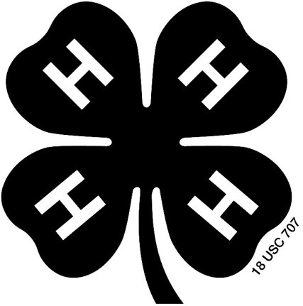

Don’t forget to attach your 4-H story to the application!

Remember, 1 story for each area you are applying for an award in.

